About Company
About us:
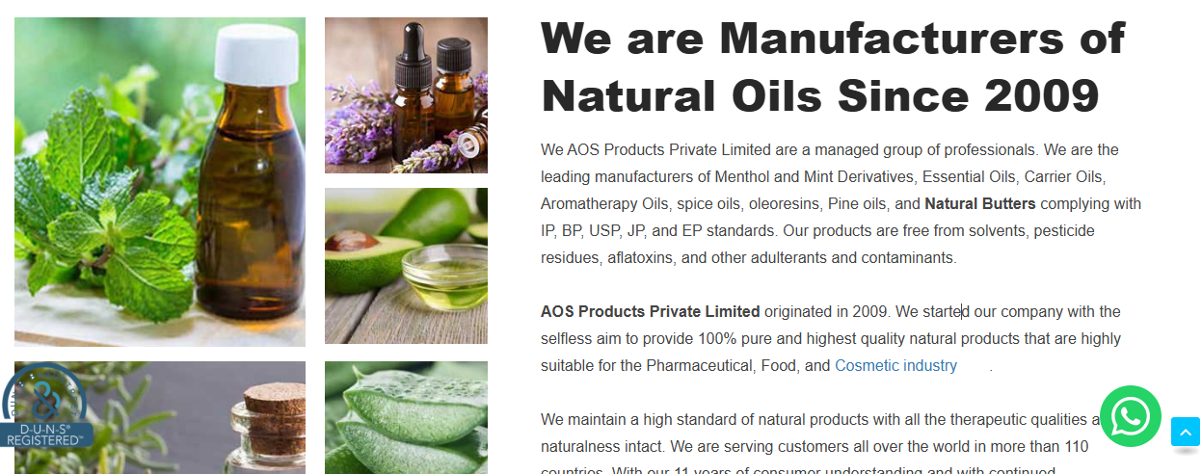
- Remove since 2009 and change it to 2020, and also remove these photos and put similar photos, because the photos don't look identical, and wherever Aos or Aos product private limited is written, it will be replaced by CSV or CSV Pharmaceuticals India Pvt. Ltd. and where 2009 is written, it will be replaced by 2020, 5 years will be replaced by 11 years
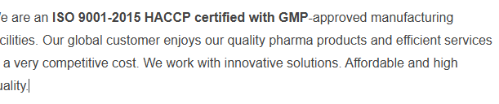
- You have to mention this ISO 22000-2015,2018 HACCP Certified instead of ISO 9001-2015 HACCP certified with GMP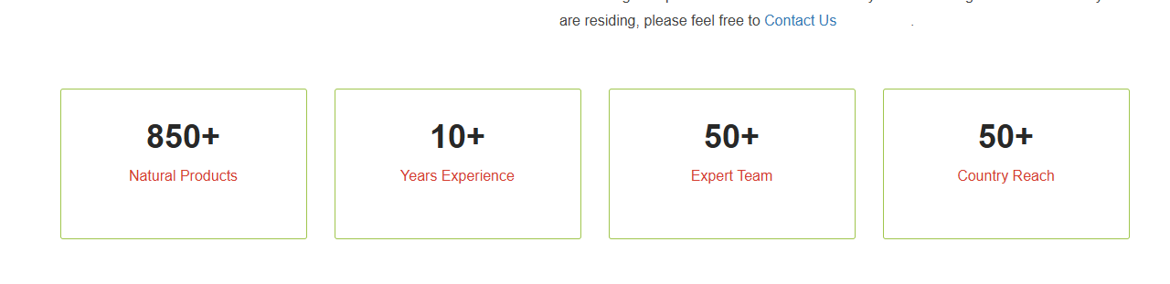
- Remove this column also.
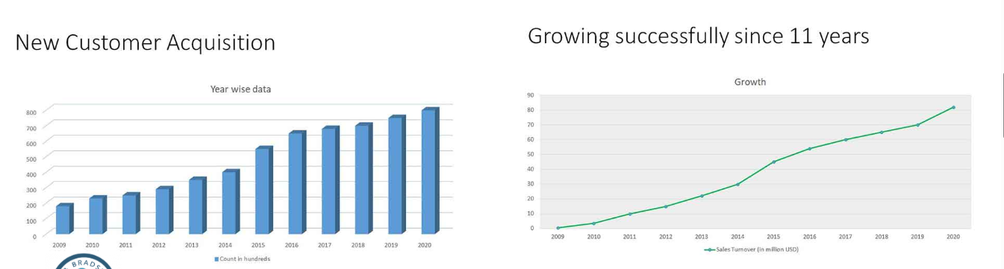
- As this graph starts from 2009. Update this from 2020 to 2025, and instead of 11 years, please specify 5 years. Our Vision and Our Mission. Please remove this and replace it with the same vision and mission that is written on our CSV site.

- Remove this column also.
Company History
- In place of the AOS Product Private Limited Business History heading, CSV Pharmaceuticals India Pvt. Ltd. Business History will be displayed, replacing AOS. Similarly, instead of AOS, CSV will be used, and where both names appear, the names of Mr. Sikandar and Mr. Avdhendra Chauhan will be included.
- And also remove a digital move--------- all things are pure.

- Remove this column also.
Business certificates
- All their certifications must be removed, while only our certifications need to be retained.

Product
- You have to add all the products in the product list, and in the menthol mint one, you have to remove the name of AOS and put our logo.
- Wherever the name of AOS is, remove it, and the name of CSV will appear, and also change the language so that it looks different.
In product
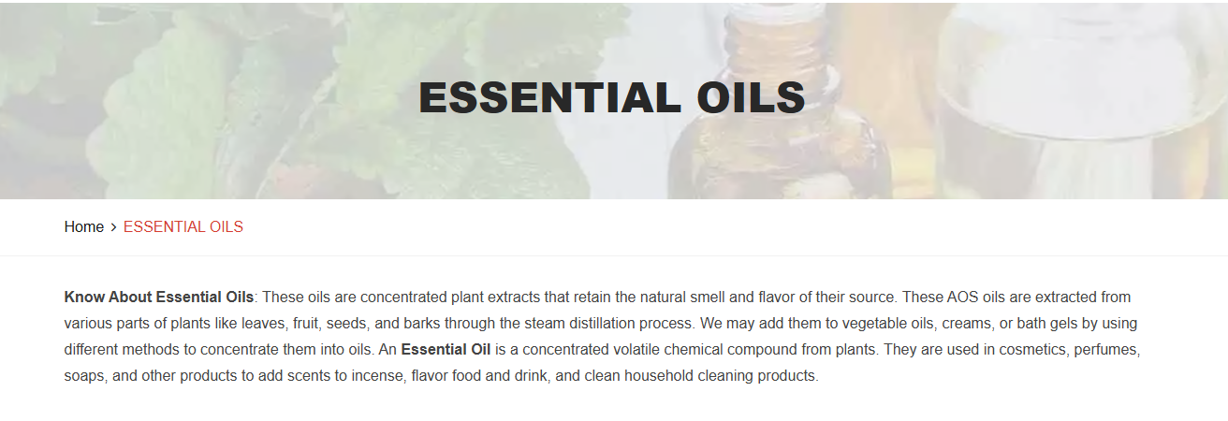
- In the theory of essential oils, we must do the same thing, namely, replace the name of AOS with the name of CSV. Where it is written 'write for us', there is a link to his contact page. Please link to our contact page.

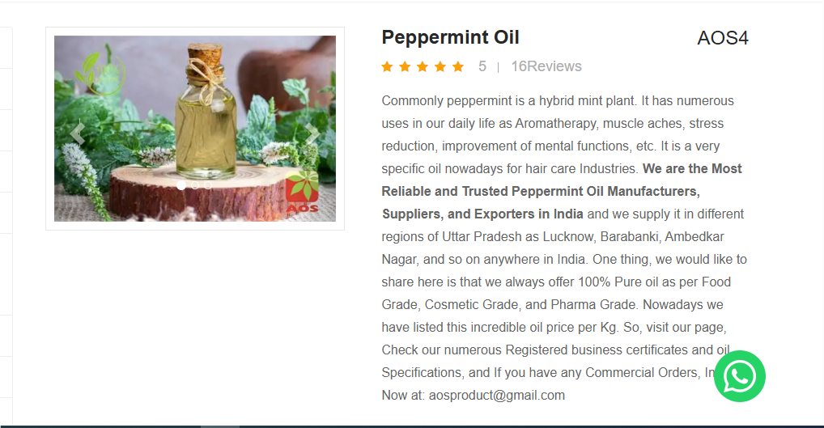

- You must remove the review stars from all product descriptions. And also remove AOS4 from all the products
- And the last line in this is their Gmail mention. Please remove it, and then you have to mention our email id exports@csvpharmaceuticals.com
- And also, you have to remove the shop online Option
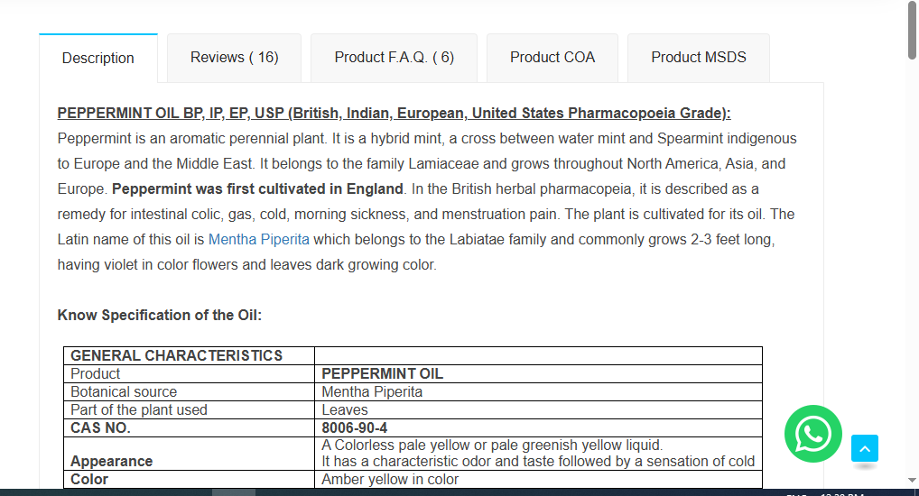
  - Now, you have to keep only the description in this column and remove all other columns like review, product FAQ, etc.
  - You should also add internal and external links in all these paragraphs, as they have done, there will be some common changes.
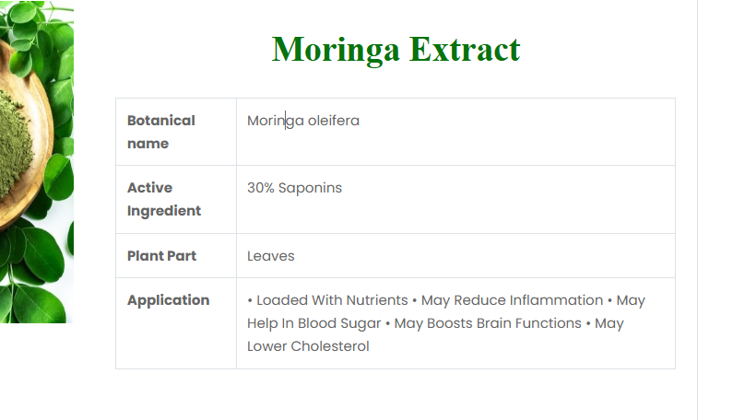
    - You need to keep the specification table in this format
    - The description will be the same, just change the language a bit and remove the name of the competitor.
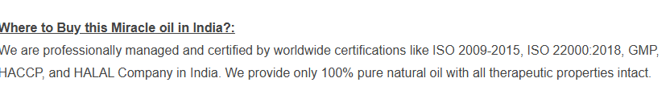
- The ISO certificate will change, and this will replace it with ISO 22000-2015,2018 HACCP and remove GMP also.

Market Report
- Remove Market Report Column and Information.

Blog
- In your blog, you can remove the name and logo of the blog, change the image, and change the language of the content and post only a few blog posts.

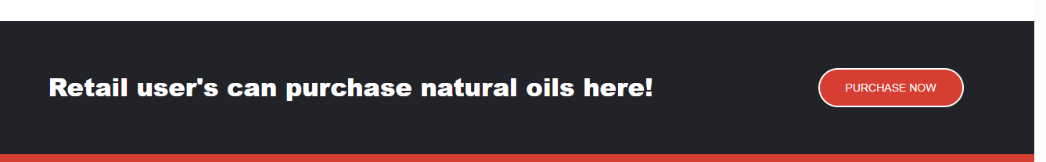

- Remove this column also.

Events
- I want to keep the Events column, but I don't want to add any events to it.

Career
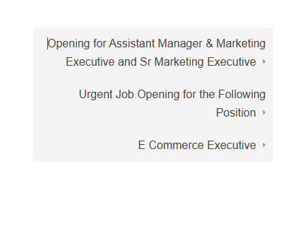
- Add this Column. Keep this also Editable so that we can edit it.

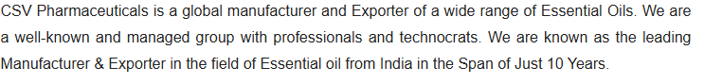
- Wherever you have written 10 years, it will be replaced by 5 years.



- Remove this Column.

Contact us:

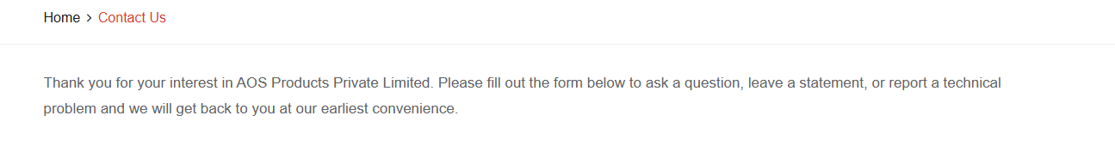

- Please paste this in place of this paragraph

Thank You for Contacting CSV Pharmaceuticals India Pvt. Ltd.!
We’re glad you’re interested in connecting with us. Whether you have a question, want to learn more about our products, or simply wish to share your thoughts, please fill out the form below. Our team will get back to you as soon as possible with the information you need.
We look forward to hearing from you!

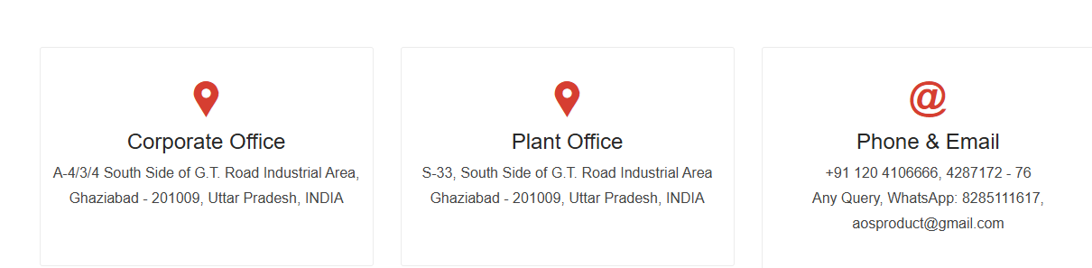

Change these addresses
  - Corporate office:-Plot no A 203, Sector 69, Noida, Uttar Pradesh, 201301, INDIA
  - Plant office:-MAUZA SIDCUL INDUSTRIAL AREA SIDCUL, Dehradun, Uttarakhand 248197, INDIA
- Phone & Email ID:- +91-7837808759 ; +91-7428856504 exports@csvpharmaceuticals.com

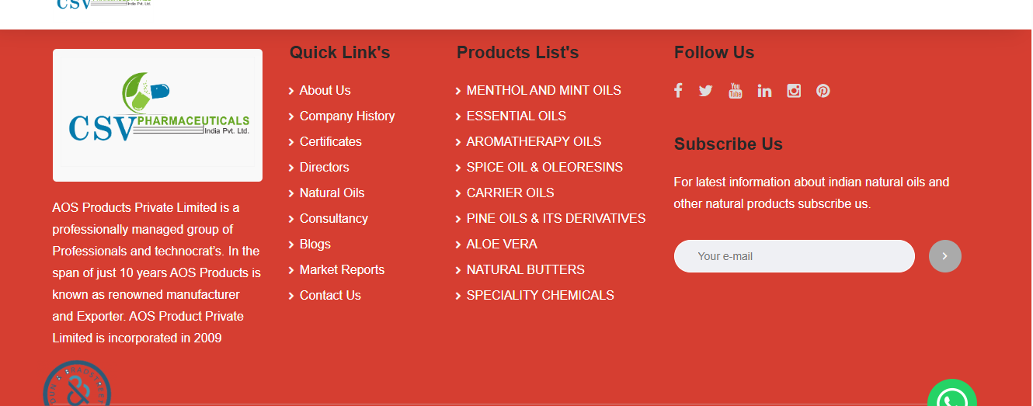

- The name of AOS has to be removed, CSV has to be written, 5 years has to be written instead of 10 years, and 2020 instead of 2009

In Quick Links
- Remove consultancy and market report.
- And putting the product list series-wise in alphabetical order



- You have to change this line to write All rights reserved 2020 -2025 @ CSV Pharmaceuticals India Pvt. Ltd.

Key points:
- Please keep the site you create Editable so that we can change or update your site.
- You have to keep the content the same, just change the language a little so that there is no issue of copying or copyright, the site looks change, and it will look different.
- Remove consultancy point
Aromatic chemicals will replace specialty chemicals.

- Keep the event option also Editable so that we can edit it

